**Conococheague Pioneer Times**

**The Newsletter of the Conococheague Institute**

January 2016 Volume 22, Issue 1

**Board of Directors**

*Tad Miller, President*

*Betty Jane Lee, Treasurer*

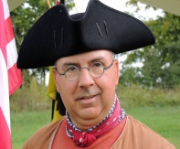*Dr. John C. Stauffer, Founder & President Emeritus*

*Chris Ardinger, Vice President*

*David G. Bell*

*Rick Read*

*Jim Rogers*

*William Sanders*

*John R. Stoner*

*Willa Weller Kaal, Secretary*

**Advisory Board**

*Dr. Doris Armstrong-Goldman*

*Calvin Bricker*

*Gay Buchanan*

*Merle Elliott*

*Tom Finucane*

*Peggie Potts*

*Dr. Martha E. Stauffer*

*Roger Swartz*

**Staff**

*Clifford Smith, General Manager*

*Shirley Shatzer, Administrative Assistant*

*Mary S. Hartman, Manager of Collections*

*& Resident Caretaker*

*Rachel B.K. Nichols, Development Coordinator*

*Joan Rockwell and Donna Lutzow,*

*Library Assistants*

**Mailing Address**

*12995 Bain Road*

*Mercersburg, PA 17236*

*Phone: (717) 328-3467*

*Fax: (717) 328-2800*

*info@cimlg.org*

*www.cimlg.org*

*www.cimlg.org/blog*

*www.facebook.com/conococheagueinstitute*

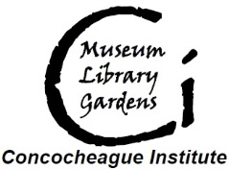

***A Message from the President***

By Tad Miller

I am both honored and humbled to have been elected as the new president of the Conococheague Institute (C.I.). Leighton Wolffe did an excellent job during his tenure and has left me with a strong organization to work with. I am especially looking forward to working closely with our General Manager, Cliff Smith. Cliff and I have seemed to hit it off quite well and I am sure that we can continue to increase C.I.’s value to the community.

For those of you who do not know me, let me tell you a little about myself. I was born and raised in Michigan and after graduating from college joined the Air Force as a communications officer. My twenty years of service took me all over the world, including a stint in Saudi Arabia in 1990 and ‘91. My last duty station was the Pentagon and when I retired eleven years ago my wife and I started looking for the perfect place to retire. We had often visited Pennsylvania, and to no surprise we found that place in PA. We bought an 1829 stone house by a covered bridge in Cumberland County. While my degree is in physics, history has always been a love to me. I have volunteered, and continue to volunteer at several museums, such as Fort Frederick in Washington County Maryland, the Smithsonian’s National Museum of American History, and the Cumberland County Historical Society. I am an 18th century reenactor and am always interested in visiting historic sites. I first came to C.I. for the Colonial Fair a decade ago and have been coming back ever since.

I was brought onto the board of directors because of my contacts in the living history world. I have been in both French & Indian War and Revolutionary War units, as well as doing civilian reenacting for over two decades. I believe if we study history we can learn past mistakes avoid repeating them ourselves. I believe that museums, historical societies and historic sites have a duty to teach the public, both on site and in the schools.

One way to do that is to make history fun through hands on activities and interaction with guides in period dress.

(Continued on next page)

So, in 2016 it is my intent to have some living history activity at C.I. every weekend from spring to fall. It may be something as elaborate as our Rural History Festival @ Rock Hill Farm or an encampment by a reenacting unit, or

smaller activities such as a class or workshop on a rural or

historical skill, or even one docent in period dress working in the garden. Whatever it is, I want visitors to see the site alive and feel welcomed to join in themselves.

Alas, I can’t do it all by myself. I need you, the members, to join me in these endeavors. Even if you have never reenacted or never volunteered at a museum or historic site before we need you and can teach you how to work with the public and how to have fun doing it.

So, watch our website for announcements of one day training classes this winter to get you ready to work with our visitors. I am looking forward to meeting you in person and working side by side with you as we make our site the place where people will come visit to learn and have fun. I look forward to hearing from you.

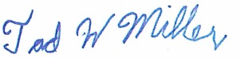 Miller1t@yahoo.com

***Seed Savers Exchange***

***Plan for Spring Planting, Now!***

By Mary Hartman, Collections Manager

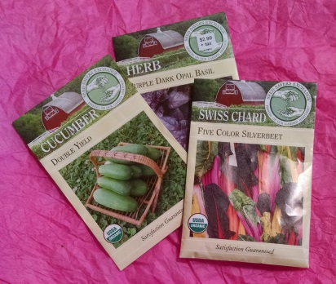We joined Seed Savers this past spring and purchased seed for resale in our gift shop. There are two ways you can get your seed: 1. Come shop in our gift shop. 2. Or go to [www.seedsavers.org](http://www.seedsavers.org) to view what’s available or request a catalog, then call or send an email to us here at C.I. with the item number and name of your choices. If we do not have the seed in our collection, we will order it. Live a distance away? No problem, we’ll mail your choices for the cost of the postage.

Some of the varieties that were most popular and tasty are Golden Beets, Double Yield Cucumbers, Rattlesnake Beans, Dragon Carrots, Rattlesnake Beans, and Torch Sunflower. Many of their selections are heirloom varieties they have worked to keep from becoming extinct.

.

We’d be more than happy to be the seed supplier for your 2016 garden!

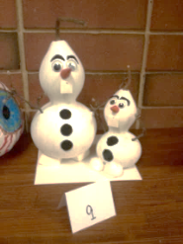

Gourds grown at C.I. became Olaf the Snowman from the Disney Movie “Frozen” made by JBHS students of Ms. Sally Haver.

***From the General Manager***

By Clifford Smith

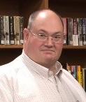Happy New Year! It is hard to believe I have been at C.I. for six months. Time has flown by as I have immersed myself in learning the wonderful world of the Conococheague Institute. Now the real work begins. Looking at the schedule for 2016 I see we have an aggressive schedule of events, seminars and demonstrations planned for the upcoming year.

Our first major event will be the Swine, Wine and Roses event on May 21 and 22. Capitalizing on our magnificent rose plantings, the Annual Rose Walk is being grown into an event with a broader appeal. The Winfield Scott Hancock Society will be here to interpret 1820s history as they did last August. We will also have BBQ pork in various forms and several local wineries on site. This event will also be a major fundraiser for us.

We are also planning a major agricultural history event for summer/fall. For nearly 300 years Franklin County has been a leader in PA agriculture. This event will celebrate our diverse and extensive agricultural past. We have everything from orchards and organic vegetables, to dairy and grain farming. You will also see sheep and Alpacas grazing on the green hills of the area. All of this is directly related to the history and development of our nation.

The Board of Directors and staff are committed to continuing to make C.I. a destination of distinction. In order for us to accomplish this goal we need your help. We need volunteers. WE NEED YOU! So, if you love history or flowers or just having fun, please call or visit and let us show you how you can help make C.I. all that it can be. We have something for everyone – gardens to tend, tours to give, research to perform, programs to share, funds to raise, repairs to be made, and so on and so on. We are in the process of developing a plan for adding more animals to the site to increase our growing list of displays and historical demonstrations. Heritage varieties on the Livestock Conservancy priority list, including fowl, sheep and pigs more heritage sheep and pig will be included.

The ‘Jig is growing and ready to make a leap forward. Please consider how you might make a difference. Together we can accomplish much. Whether you have an hour, a day or a week, we can use your help. The American spirit is about coming together for the greater good. Day by day, CI is moving in the much needed direction of community building and teaching -- sharing your knowledge and wisdom with each other and then sharing it with the public. Come and visit us and see all the new and exciting things happing at C.I.

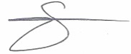

***What Is Our Intern Doing?***

By Lucas LaPole

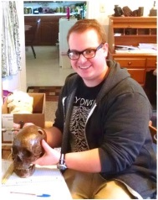Upon my arrival, in mid-October, I was assigned to work on the significant number of recent artifact donations that had yet to be properly. So, the major part of my time has been spent cataloging, documenting and tagging artifacts in preparation for public display or proper storage. Since then, several hundred individual artifacts have been added to the institute’s digital cataloging system, PastPerfect. This time consuming work is a necessary undertaking before new exhibits can be properly designed. Furthermore, proper cataloging contributes to the security of artifacts that are on public display.

I have been lucky enough to spend the bulk of my time working with the collection donated by Dr. William Lee Davis and his wife Janet. Perhaps my favorite artifacts to catalog have been the 18th century medical and dental tools and devices. While somewhat gruesome, the opportunity to handle and research an actual amputation saw and a set of tooth extraction devices was a fascinating experience. The medical equipment, now that is has been properly cataloged, will soon be installed in secure cases, a kind donation from the Mercersburg Academy, and will be on display once again.

In conjunction with my cataloging work, I also implemented a major upgrade to the online component of PastPerfect, our object catalog. By going to <http://conococheague.pastperfectonline.com/>, or by following the link available on the left side of <http://cimlg.org/>, anyone can search through our collection of objects, books, photographs and archival materials. This site will now be updated regularly as more of the collection is cataloged, and should be a useful research tool.

Finally, I am in the early stages of planning for the future conversion of the blacksmith shop into a fully functional colonial tavern in order to highlight the central role that taverns played in colonial frontier communities. While the exact details of the project are not fully fleshed out as of now, I am diligently researching colonial tavern life, and am extremely excited about this particular endeavor.

*Lucas is at C.I. on an internship through Shippensburg University where he is nearing completion of his Master’s Degree in History.*

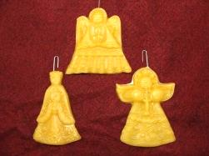

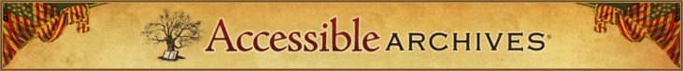NEW -- Accessible Archives honors Black History Month with special additions on the following databases: African American Newspapers: The 19th Century, The Liberator and National Anti-Slavery Standard. These primary source collections are a key component in following the struggles for freedom and justice by leaders and participants in the abolitionist movement.

Just published!

***James McCullogh’s Book: A Glimpse into Life on the Colonial Frontier***

By John Stauffer and Calvin Bricker

In 1745, a 25-year-old Scot-Irish man purchased a small leather-bound notebook in the port city of Belfast, Ireland. Less than a year later, James McCullogh and his young wife Martha made the arduous voyage across the Atlantic to a new life to the Pennsylvania frontier. Over the next 15 years, James McCullogh wrote in what he calls on the first page “My Book” notations from his life, giving us today a glimpse into frontier life in the mid-18th century.

Now, after years of research and study by Dr. John Stauffer and Calvin Bricker, with contributions from many associated with CI, ***James McCullogh’s Book: A Glimpse into Life on the Colonial Frontier*** has been published.

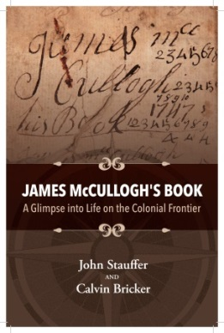A fascinating read, the book shares the story of one of those people who are often unrecognized by history, but who did the actual work to civilize and build this country. Through his notations, McCullogh shares the details of his work life as a farmer and linen maker at a time when settlers lived in mortal fear of Indian attacks. Deeply religious, he uses Bible verses to deal with the tribulations of daily life that included the likely murder of his brother John and the kidnapping of his two small sons at the hands of Indians unhappy at losing their lands. Sometimes writing in code and sometimes in enigmatic exclamations, James McCullough gives a vivid look at the Pennsylvania frontier. It’s a story not to be missed!

***James McCullogh’s Book: A Glimpse into Life on the Colonial Frontier*** is available onsite at CI or call (717) 328-3467 to have your copy shipped to you via USPS.

**James McCullogh’s Book: A Glimpse into Life on the Colonial Frontier**, paperback, 142 pages, ISBN 978-0-9907116-2-9, $17.95, plus $5 for shipping and handling. Pennsylvania residents, please add 6% sales tax.

*Coming in 2016: a companion volume that will include the actual diary and transcription, along with commentary. Reading the present book first is advised for a useful overview.*

**Heritage Roses**

Shop at the Conococheague Institute’s gift shop for items you won’t find in a big box store. Ceramics, wooden toys, note cards, heritage seed varieties, wonderful books, home décor***,*** *Scherenschnitte* (German paper cuttings), and more. Contact Mary at 717-328-3467 for assistance. Special orders are available and we will even ship your purchases to you, if needed for a small shipping and handling fee. **Beers**

**1820s Farm Life**

***Recent Donation and Grant***

At the end of 2015, C.I. received a generous $10,000 donation from Lifetime members Robert and Marilyn Kurtz. The funds will provide seed money for developing partnership projects between the Mercersburg Academy and C.I.

Mr. Kurtz is an alumnus of the Mercersburg Academy who has pursued a lifelong passion for history. There is an endowed Chair at the Academy in the Kurtz’s name for American Studies. C.I. will be working with headmaster Douglas Hale, C.I. Board member and Academy teacher David Bell and the Kurtz Chair Emily Howley to shape programs that will benefit both organizations and have a lasting effect on visitor experience at C.I.

The C.I. Library is richer for the gift of Mr. Kurtz’s exquisite photo-journalism books. In Americana Roads Mr. Kurtz acts as a trail guide down some of the most famous roads, scenic pathways, and historic monuments in history. Provocative essays regarding America's changing values are coupled with his memorable photographs.

As time passes and cultures inevitably change, it gets harder and harder to imagine how we became what we are today. A Backward Look at Traveled Roads allows us to have a glimpse into the past to show you just a tip of what

formed this great and diverse world in which we live. It fits in perfectly with our new emphasis on the remarkable ingenuity of Rock Hill’s earliest settlers.

🙢🙠

C.I. has been awarded a Franklin County Tourism and Quality of Life Enhancement Grant in the amount of $47,297 to begin creating a network of accessible pathways that will allow all visitors to navigate the entire site.

Phase I will be a loop access which connects the main parking area and administration and library area to the Welsh Barrens Visitor Center and the Four-Square Garden.

Future phases will 1.) Develop a pathway west of the “loop” to provide access to the Eliab Negley House and the Native American Village display; 2.) Continue the trail system further west onto the complex that will connect the Welsh Run Wetland Woods and the Old Welsh Cemetery to the pathway system. These later phases include repair of the existing bridge, which was severely damaged in a flood June 2014.

If you are interested in assisting with the project (a project manager would be helpful), or helping procure additional funding, please contact Rachel Nichols at Rachel@cimlg.org

***Upcoming Groups, Events and Dates to Remember***

**January**

12 History Hippies, 7:00 – 8:30 p.m.

14 Sidetracks of History Book Cub

1:00 – 3:00 p.m.

**February**

9 History Hippies, 7:00 – 8:30 p.m.

11 Sidetracks of History Book Cub

1:00 – 3:00 p.m.

**March**

8 History Hippies, 7:00 – 8:30 p.m.

10 Sidetracks of History Book Cub,

1:00 – 3:00 p.m.

**SAVE THESE DATES!**

**April 2 – End of Starvation Feast**

**April 9 & 16 – Two-Day Chair Caning**

**Workshop**

**May 21-22 – Swine, Wine & Roses**

The Conococheague Institute

Museum, Library and Gardens

12995 Bain Road

Mercersburg, PA 17236



www.cimlg.org Conococheague Institute Museum & Library